**Supplementary numerical example**

**1. Collaborative design with pure hand-drawing**

During the design process, engineers frequently share their ideas with one another, often using sketches and personal insights as a basis for discussion. However, this way of communicating may lead to inaccuracies and misunderstandings, making it difficult to maintain efficiency in the workflow.

DrawTop can help engineers efficiently express both parties' design ideas through pure hand drawing. Subsequent optimization iterations can accurately and intuitively verify these design ideas.

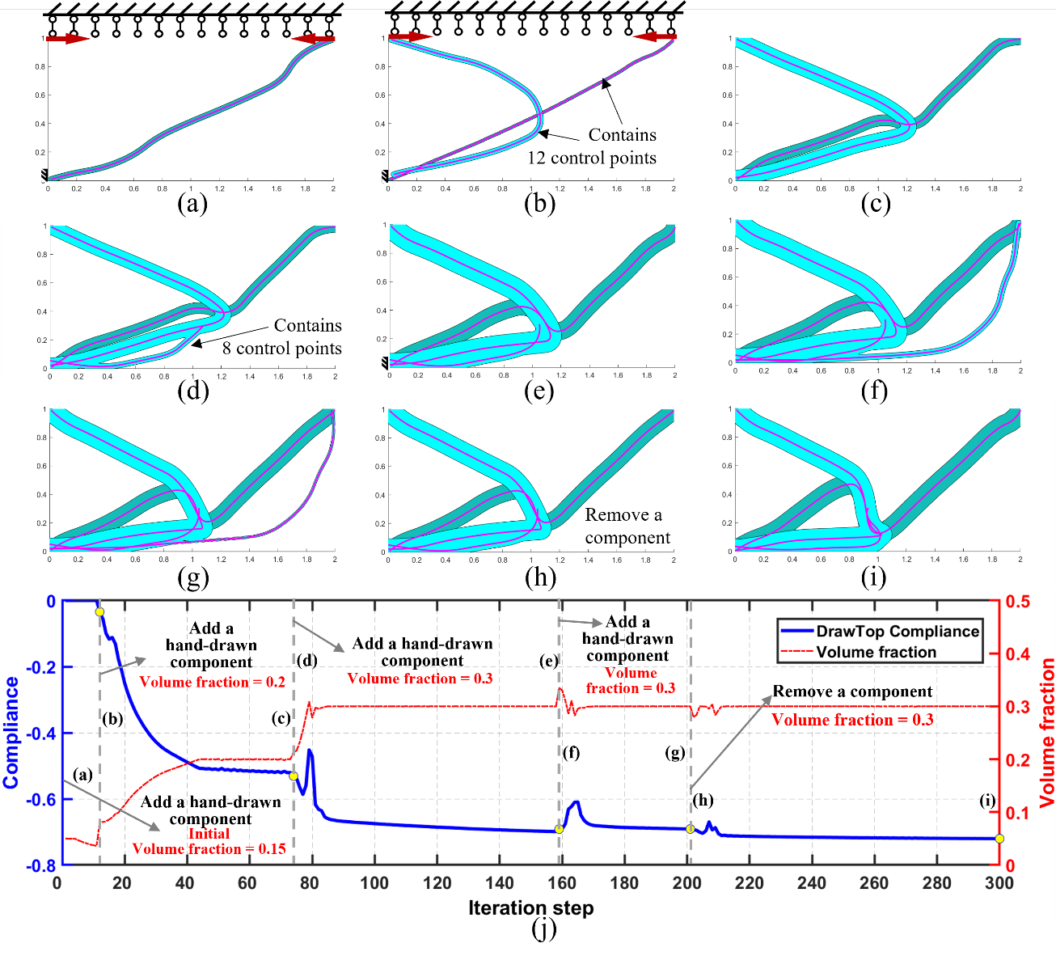

Fig. 6. Collaborative design of compliant mechanism in a hand-drawn manner

This section simulates the process of engineers collaboratively designing a compliant mechanism in a purely hand-drawn manner, as shown in Fig. 6. Initially, there is no structure in the design domain. Based on their design experience, engineers create hand-drawn components to connect the fixed constraint location and load locations, as shown in Fig. 6 (a) and (b). After optimization iterations, the two components underwent deformation and displacement, as shown in Fig. 6 (c). A new hand-drawn component is then added, as shown in Fig. 6 (d). This component gradually overlapped with the existing structures, enhancing the local structural performance, as shown in Fig. 6 (e). Subsequently, an engineer introduces another component, shown in Fig. 6 (f). However, this new component gradually became thinner and tended to disappear as the iterations progressed, as shown in Fig. 6 (g). This observation indicated that it did not significantly contribute to improving structural performance and, therefore, should be removed, as shown in Fig. 6(h). Thereafter, no further HAD operations are performed until the convergence condition is satisfied and the optimization results are obtained, as shown in Fig. 6 (i). The iteration history curve of the optimization process is shown in Fig. 6(j).

The entire optimization design process is highly interactive. Engineers can pause iterations to discuss their ideas, hand-draw components at specific locations of interest, and then resume the optimization and iteration process. By observing changes in the position and parameters of the components, they can intuitively verify the impact of their design ideas. DrawTop facilitates communication between engineers and has the potential to improve the efficiency of collaborative design.

**2. The "sensitivity shock" phenomenon**

After adding or removing components, there will usually be a significant increase in the movement or deformation range of components, as shown in Fig. 7. The reason for this is that adding or removing components causes sudden changes in the objective function and constraint functions of the structure, which in turn leads to severe distortion in sensitivity calculation and further affects the subsequent iteration process. The "shock" of adding or removing components on sensitivity will reduce the optimization efficiency to a certain extent, which may cause the optimization result to fall into other local optimal solutions, or even lead to failure in iteration convergence. The specific degree of impact is related to various factors such as the type of objective function, the type of constraint function, and the parameters of the added or removed components.

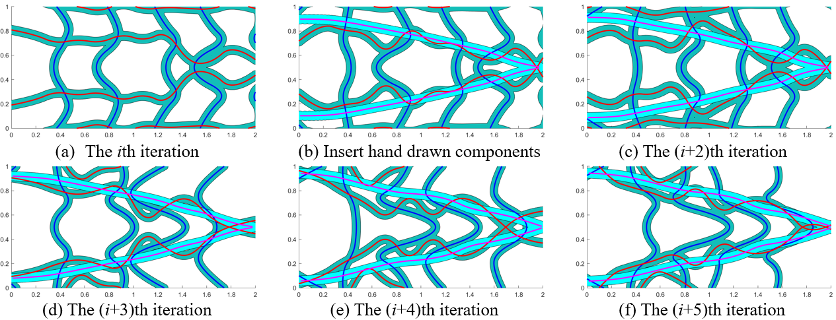

Fig.7. The "sensitivity shock" phenomenon interferes with

the stability of the iteration process

A universally applicable approach is adopted here to address this "sensitivity shock" phenomenon: during several consecutive iteration steps after HAD operations such as adding or removing components, a buffer coefficient is multiplied by the sensitivity values of all design variables. This coefficient is always a positive number and gradually increases with each iteration until it equals 1. By gradually "buffering" the suddenly occurring "sensitivity shock", this method achieves the goal of smoothly adding or removing components, and its effect is shown in Fig. 8.

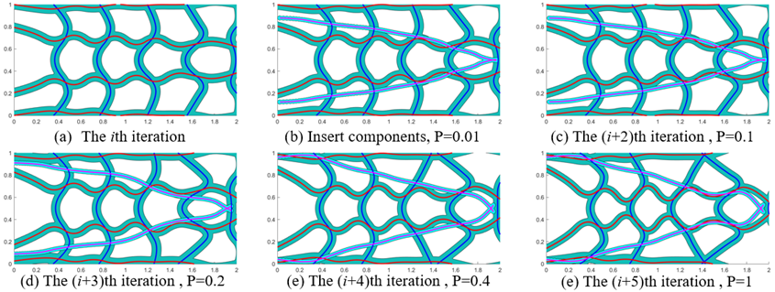

Fig.8. The iteration process after multiplying all design variables

by the buffer coefficient

It is worth noting that there is more than one way to achieve a similar effect, and only the most straightforward method is adopted here. Additionally, it should be supplemented that if only the threshold of the constraint function is modified during the iteration process, the aforementioned "sensitivity shock" phenomenon will not occur, and the iteration process can still remain stable.